SmartCare v0.5 - Architecture and Refactoring Workbook
Week 8 student resource

Current Architecture Problems
Problem | Evidence | Impact | Refactoring
Workflow coordination outside a service | Stage 4 caller/manual checks created, updated and cancelled appointments directly. | Workflow responsibilities are scattered and presentation/test code can become coupled to domain behaviour. | Introduce AppointmentService to coordinate application use cases.
No explicit repository boundary | Stage 4 had no data-access abstraction because persistence was not yet implemented. | Adding storage later could tempt SQL or storage code into Appointment or the service. | Define a small AppointmentRepository contract.
Persistence implementation could leak inward | A concrete storage class may be referenced directly if no dependency rule is followed. | Service would become coupled to one storage mechanism and harder to replace/test. | Make the service depend on AppointmentRepository; persistence implements it.
Presentation concerns can drift into domain | Manual behaviour checks used print/output code around domain objects. | Domain classes could gain UI/output responsibilities and lose cohesion. | Keep presentation in a separate presentation layer.
Business rules could be moved into the service | Cancellation/rescheduling are coordinated by AppointmentService. | If the service directly changes fields, Appointment invariants could be bypassed. | Service must call Appointment.cancel() and Appointment.update().
Missing-appointment behaviour needs a clear contract | AI review raised the risk of get_by_id() returning no object. | Unclear error behaviour can cause service failures or inconsistent handling. | Keep current repository contract: get_by_id() raises KeyError; translate later only if required.
Overengineering risk | AI review suggested no current need for frameworks, factories, microservices or extra patterns. | Unnecessary abstractions increase complexity without solving a present requirement. | Keep the architecture small and add only justified components.

Layer Responsibilities
Layer | Responsibilities | Must not contain
Presentation | Collect/display user input and output; call service operations. | Business rules, SQL, repository implementation details.
Service | Coordinate use cases such as schedule, get, reschedule and cancel. | Direct SQL, UI code, duplicated Appointment business rules.
Domain | Own entity state, validation and business invariants. Appointment controls legal status transitions. | UI, SQL, persistence logic, notification/service dependencies.
Repository | Define the storage contract required by current use cases: add, get_by_id and save. | Database-specific implementation details or presentation logic.
Persistence | Implement the repository contract and store/retrieve Appointment objects. | Business-rule decisions that belong to Appointment or workflow logic that belongs to Service.

Architecture Diagram
SmartCare v0.5 layered architecture: Presentation -> Service -> Domain, with Service depending on the AppointmentRepository abstraction and Persistence implementing it.
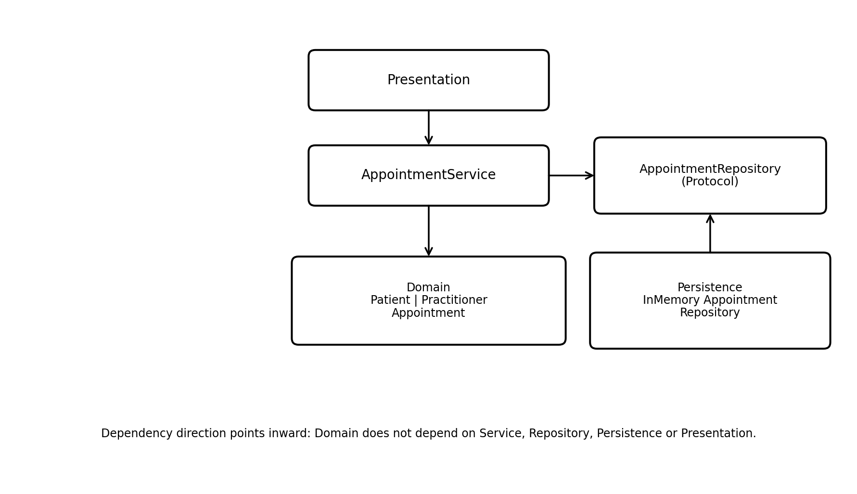

SOLID Review
Principle | Relevant? | Evidence | Decision
SRP | Yes | Appointment owns domain rules; AppointmentService coordinates use cases; repository handles storage. | Keep responsibilities separated as currently designed.
OCP | Partly | A new persistence implementation can be added behind AppointmentRepository without changing AppointmentService. | Current design is sufficient; no extra extension framework needed.
LSP | Limited | There is no inheritance hierarchy in the current design, so there is little current LSP risk. | Do not introduce inheritance unless a genuine 'is-a' relationship is confirmed.
ISP | Yes | AppointmentRepository is deliberately small: add(), get_by_id() and save() only. | Keep the repository contract focused on current use-case needs.
DIP | Yes | AppointmentService depends on AppointmentRepository (Protocol), not InMemoryAppointmentRepository. | Keep the abstraction; no additional repository interface is needed.

AI Architecture Review
AI suggestion | Observed problem? | Decision | Reason | Verification
Keep Appointment business rules in the domain and use the service only for orchestration. | Yes | Accepted | The AI correctly identified this as good separation of concerns and high cohesion. | Service calls Appointment.cancel() and Appointment.update() rather than mutating fields directly.
Keep schedule() simple; do not add notifications, logging, frameworks or extra patterns without requirements. | Yes | Accepted | This avoids overengineering and preserves a focused service responsibility. | No unsupported dependencies were added.
Handle the possibility that get_by_id() returns None. | Not exactly | Modified | The concern is valid, but the current InMemoryAppointmentRepository raises KeyError rather than returning None. | Missing IDs produce KeyError under the current repository contract; service can translate it later if required.
Introduce a repository interface if the system grows. | No | Rejected | AppointmentRepository is already defined as a Protocol, so the abstraction already exists. | AppointmentService type-hints AppointmentRepository, not the concrete in-memory implementation.
Avoid direct assignment such as appointment.appointment_time = ... in the service. | Risk only | Accepted as design rule | Direct mutation could bypass domain validation if introduced later. | Current service uses Appointment.update(), so no refactoring was needed.
Current architecture has no obvious layer violations and low overengineering risk. | No current violation | Accepted | The review supports keeping the current structure rather than adding complexity. | Required schedule/get/reschedule/cancel behaviour remains unchanged.

